ATTRIBUTE-BASED HIERARCHICAL ACCESS CONTROL
WITH EXTENDABLE POLICY

A Study Report on the Paper by M. Xiao, H. Li, Q. Huang, S. Yu and W. Susilo
IEEE Transactions on Information Forensics and Security, Vol. 17, 2022

Arya Mirani
Roll No: 2024101145

Date of Submission: 11-Nov-2026

Abstract
Ciphertext-Policy Attribute-Based Encryption (CP-ABE) is a widely used mechanism for fine-grained, one-to-many access control over encrypted data in the cloud. However, most existing CP-ABE schemes treat every piece of data and its access policy in isolation, even when the policies of several related files are themselves related in a hierarchical way. This report studies the paper “Attribute-Based Hierarchical Access Control With Extendable Policy” by Xiao et al. (IEEE TIFS, 2022) [10], which proposes Extendable Hierarchical CP-ABE (EH-CP-ABE). The scheme (i) encrypts a whole family of hierarchically related data items under a single access tree in one pass, and (ii) allows the data owner to extend an existing ciphertext's access structure — either externally (adding a new root above the tree) or internally (adding a new branch inside the tree) — to cover newly shared data, without re-encrypting everything from scratch. The scheme is proven IND-CCA secure in the random oracle model under the Computational Bilinear Diffie-Hellman (CBDH) assumption (given an IND-CCA-secure symmetric cipher), and is shown experimentally to be significantly more efficient than repeated, separate CP-ABE encryption. We implemented the scheme in Python, re-ran the paper's experiments, and confirmed its efficiency trends. We also found that the hierarchy does not always enforce each sub-policy: when a data item hangs below an OR or k-of-n gate, any user who satisfies that gate can decrypt the item (Section 7.3).
Keywords: Attribute-Based Encryption, Ciphertext-Policy ABE, Hierarchical Access Control, Extendable Policy, Cloud Data Sharing, Bilinear Pairing.
Implementation (code repository): https://github.com/aryamirani/eh-cp-abe

Section 1: Introduction
Cloud computing lets organizations offload storage and computation, but this convenience comes at the cost of data confidentiality: the cloud service provider (CSP) is an untrusted third party and should not be able to read sensitive data it stores. The standard remedy is to encrypt data before uploading it, but plain symmetric or asymmetric encryption does not scale to fine-grained, one-to-many sharing — a data owner would need to encrypt a separate copy of the data for every possible recipient or group. Attribute-Based Encryption (ABE), introduced by Sahai and Waters [1] and later split into Key-Policy ABE (KP-ABE) [2] and Ciphertext-Policy ABE (CP-ABE) [3], solves this by binding an access policy over descriptive attributes (e.g. “Team A”, “Manager”) either to the decryption key or to the ciphertext. In CP-ABE, the data owner attaches the policy to the ciphertext, which gives the owner full discretion over who can decrypt — making CP-ABE the more natural fit for cloud data sharing.
The paper identifies two practical weaknesses of standard CP-ABE. First, access policies for related pieces of data are handled in isolation even when they are hierarchically related. For example, a manager may want task M_{A} accessible to “Team A OR Team B” (policy T_{A}), and a related task M_{B} accessible only to “(a participant in task X) AND (Team A OR Team B)” (policy T_{B}). Policy T_{A} appears as a sub-tree of T_{B}: T_{B} is T_{A} with one more AND condition. Conventional CP-ABE still encrypts M_{A} and M_{B} completely separately, repeating work that the hierarchical relationship makes redundant. Second, access policies are fixed at encryption time: if the owner later wants to share a related item under a policy that extends the original one (by adding an AND/OR/OUT-OF condition, i.e. an “external” extension that wraps the old policy, or an “internal” extension that adds a new branch inside it), most existing schemes offer no way to reuse the earlier encryption (the few that do, [5] and [6], only extend the policy of the same data through an OR or AND gate) — the owner must re-encrypt from zero.
To address both problems, Xiao et al. [10] propose Extendable Hierarchical CP-ABE (EH-CP-ABE). It represents a whole family of related access policies as a single hierarchical access tree, where every internal node of the tree is itself the root of a valid access policy for one piece of data. The data owner encrypts the whole family at once. Later, the owner can extend the tree — externally by adding a new root above the existing tree, or internally by adding a new subtree below an existing internal node — to bring in new data under a broadened policy, while leaving most (often all) of the previous ciphertext untouched. The scheme is proven IND-CCA secure and evaluated experimentally against a baseline CP-ABE implementation.

Section 2: Literature Review
Sahai and Waters (2005) [1] introduced fuzzy identity-based encryption, the conceptual root of ABE. Goyal et al. (2006) [2] formalized KP-ABE, where the access policy is embedded in the decryption key and the ciphertext just carries a set of attributes. Bethencourt, Sahai and Waters (2007) [3] proposed the first CP-ABE construction using a tree-based access structure with threshold gates at internal nodes and attributes at the leaves — this tree formalism is the basis that EH-CP-ABE extends.
On the hierarchical side, Gentry and Silverberg (2002) [7] proposed the first hierarchical identity-based encryption scheme. Wang et al. (2010) [8] and Wan et al. (2012, HASBE) [9] brought hierarchy into ABE from the authority side — a central authority delegates key generation to domain authorities responsible for different attribute sets — which reduces the load on a single authority but does not address hierarchical relationships between the data itself. Closer to this paper, Wang et al. (2016) [4] proposed a file-hierarchy CP-ABE scheme that integrates several files' policies into one access structure organized into explicit levels, with extra “transport nodes” connecting the levels. This scheme reduces encryption cost for related files, but is inflexible: it requires files to sit at successive levels of the tree rather than letting an arbitrary subtree represent a policy, and it adds computation for the transport nodes.
On the policy-extension side, Susilo et al. (EACSIP, 2017) [5] let a data owner add a new access policy to the same data, which is effectively an OR-gate external extension (more users can now access the data). Huang et al. (DACSC, 2018) [6] extended this with a restrictive extension (narrowing access, similar to an AND-gate extension) alongside the non-restrictive one. Separately, Jiang et al. [11], [12] used proxy re-encryption to update access policies, but support only AND-gate policies; Li et al. [13] support monotone access structures, again via proxy re-encryption. Both need a re-encryption key generation step to assist the update. None of these schemes combine hierarchical multi-data encryption with general (AND/OR/OUT-OF, external or internal) policy extension — which is precisely the gap EH-CP-ABE fills.

Section 3: Proposed Scheme — EH-CP-ABE

3.1 System Architecture and Design Goals
EH-CP-ABE involves four entities. The attribute authority holds the master secret key and issues decryption keys to data users after verifying their attributes; it is assumed trusted. The data owner encrypts a series of hierarchically related data items with a set of symmetric keys, and protects those symmetric keys with a single hierarchical CP-ABE ciphertext that encodes all the related access policies at once. Data users request a decryption key for their attribute set from the authority, and can decrypt whichever piece(s) of data their attributes satisfy. The cloud server simply stores and serves the ciphertext to anyone who asks — all the confidentiality guarantees come from the cryptography, not from access control at the storage layer. Fig. 1 shows the four entities and the messages exchanged between them.
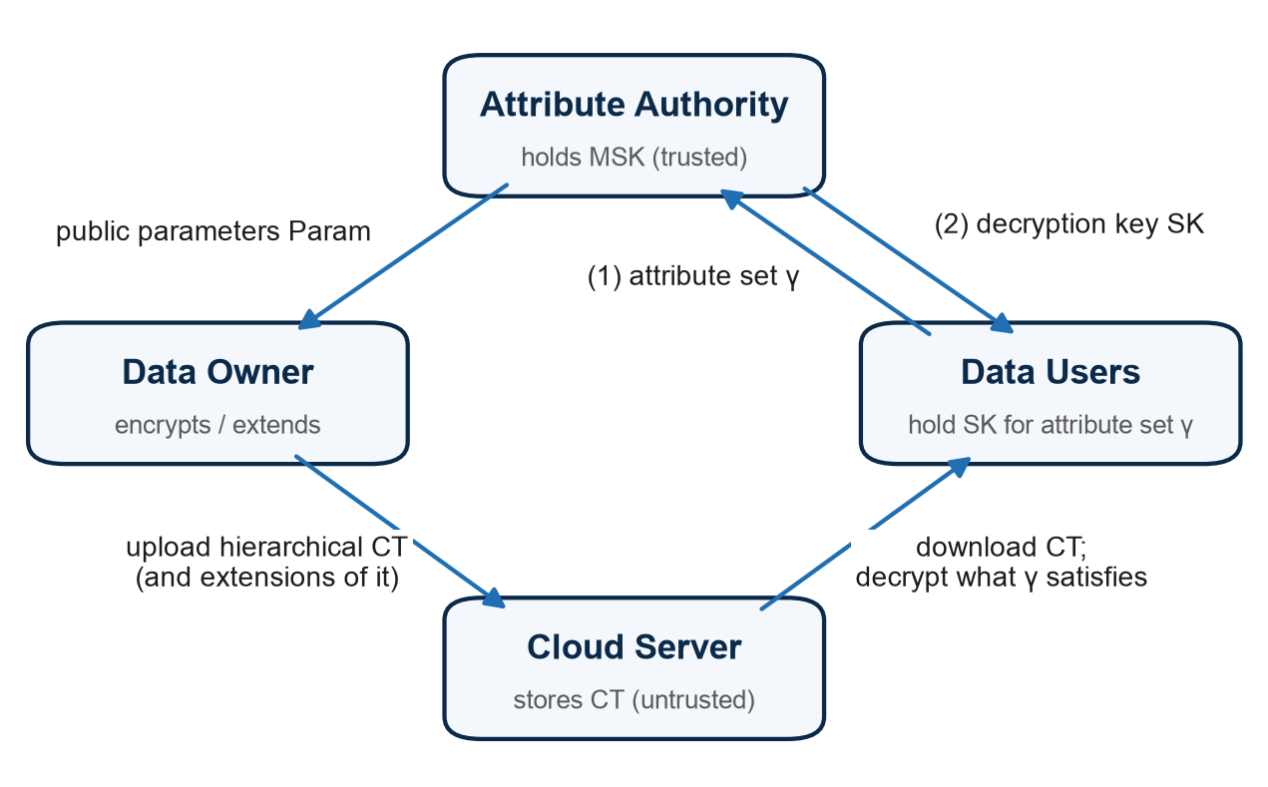
Fig. 1. System model of EH-CP-ABE.
The design targets three goals: (1) hierarchical access control — encrypt many related data items in one pass instead of one ciphertext per item; (2) external extension — let the owner wrap the existing access tree under a new, broader root to admit more data, without touching the original ciphertext; and (3) internal extension — let the owner graft a new subtree onto an existing internal node, with at most a minor update to the part of the ciphertext below that node.

3.2 Hierarchical Access Tree
The access structure is a tree T where every internal (non-leaf) node x represents a threshold gate — an AND-gate, OR-gate, or general OUT-OF-n gate — with a threshold value k_{x} out of num_{x} children, and every leaf node represents a single attribute. What makes the tree “hierarchical” is that every internal node x is also treated as the root of its own sub-tree T_{x}, and each such sub-tree is bound to one piece of data M_{x}: satisfying the policy encoded by T_{x} (i.e. T_{x}(γ) = 1 for an attribute set γ) is exactly the condition for decrypting M_{x}. Each sub-tree is therefore a part of the policy of every one of its ancestors, so a single tree captures a whole family of related policies at once, instead of needing one independent tree per file as in ordinary CP-ABE. Whether a deeper node's policy is stricter or looser than its ancestor's depends on the gates in between: below an AND gate the parent is stricter than the child (it also demands the child's siblings), while below an OR gate the parent is looser. In Fig. 2, for example, M_{D} needs d1, d2 and d3, whereas M_{B} = “b1 OR T_{D}” is obtainable with b1 alone.
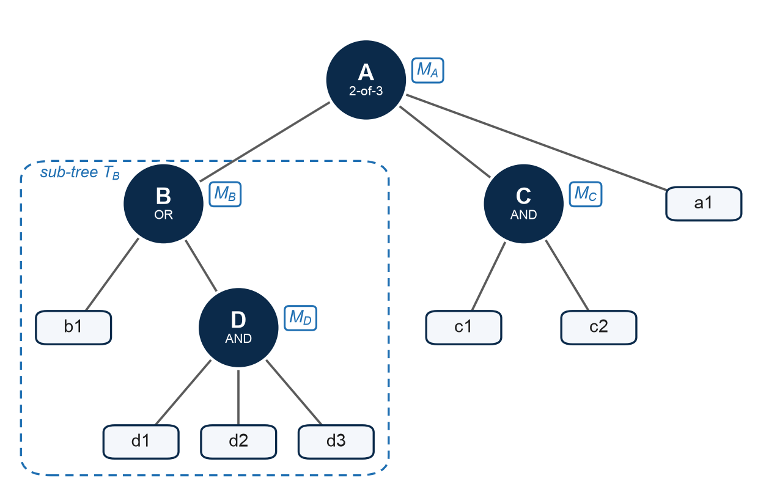
Fig. 2. A hierarchical access tree (after Fig. 5 of [10]): every gate is bound to one message; the sub-tree T_{B} rooted at B is the policy of M_{B}.

3.3 Core Algorithms
Setup takes a security parameter 1^{δ}. The attribute authority chooses a bilinear group 𝔾₀ of prime order p with generators g and h = g^{β}, a bilinear map e: 𝔾₀ × 𝔾₀ → 𝔾_{T}, two hash functions H₁: {0,1}* → 𝔾₀ and H₂: 𝔾_{T} × 𝔾₀ × 𝔾_{T} → {0,1}^{l} (l is the symmetric key length), a symmetric scheme (E, D) and random exponents α, β ∈ ℤ_{p}, and outputs the public parameters and master secret key:
$$Param = \{𝔾_{0}, 𝔾_{T}, e, p, g, h = g^{β}, H_{1}, H_{2}, e(g,g)^{α}, (E, D)\}, MSK = \{β, g^{α}\}$$
KeyGen takes MSK and an attribute set γ, picks a random r ∈ ℤ_{p} and a random r_{i} ∈ ℤ_{p} for every attribute i ∈ γ, and outputs the decryption key
$$SK = \{ D = g^{α}h^{r}, D_{i} = g^{r}·H_{1}(i)^{r_{i}}, D′_{i} = h^{r_{i}} \} ∀ i ∈ γ$$
The key is bound to an attribute set rather than to an individual identity, which is what allows several users with the same attributes to share a key structure.
Encrypt is the core hierarchical-encryption routine. Given a hierarchical access tree T over a series of messages {M₁, …, M_{|X|}}, it first generates, top-down starting at the root, a random polynomial q_{x} of degree d_{x} = k_{x} − 1 for every node x, chosen so that q_{x}(0) = q_{parent(x)}(index(x)) — the standard Shamir-style secret sharing used in tree-based CP-ABE [3]. The key difference from ordinary CP-ABE is that instead of using only the root's constant term to derive one encryption key, EH-CP-ABE extracts the constant term σ_{x} = q_{x}(0) of every internal node x and uses it to protect a symmetric key K_{x} that encrypts the data M_{x} bound to that node. One traversal of the tree therefore yields as many usable encryption keys as there are internal nodes, each protected by the access policy of its own sub-tree. For each non-leaf node x ∈ X the owner picks a random R̂_{x} ∈ 𝔾_{T} and computes
$$C_{x}^{(1)} = {R̂}_{x}·e(g,g)^{ασ_{x}}, C_{x}^{(2)} = g^{σ_{x}}, C_{x}^{(3)} = E_{K_{x}}(M_{x}), K_{x} = H_{2}(C_{x}^{(1)} ‖ C_{x}^{(2)} ‖ {R̂}_{x})$$
and for each leaf node y ∈ Y
$$C_{y} = h^{q_{y}(0)}, C′_{y} = H_{1}(att(y))^{q_{y}(0)}$$
giving the integrated ciphertext below. The owner also keeps every σ_{x} (stored encrypted as C_{σ}) for later extensions. (Internal extension Case 1 in fact needs the whole polynomial q_{C}, not only σ_{C}; see Section 7.1.)
$$CT = \{T, \{C_{x}^{(1)}, C_{x}^{(2)}, C_{x}^{(3)}\}_{∀x∈X}, \{C_{y}, C′_{y}\}_{∀y∈Y}\}$$
Decrypt lets a user holding SK over attribute set γ recover any M_{x} whose sub-tree T_{x} is satisfied by γ. The recursive DecNode procedure of [3] runs bottom-up; on a leaf y with i = att(y) ∈ γ it computes
$$DecNode(y) = e(D_{i}, C_{y}) / e(D′_{i}, C′_{y}) = e(g,g)^{rβq_{y}(0)}$$
and on a non-leaf node it combines k_{x} satisfied children by Lagrange interpolation in the exponent, giving DecNode(x) = e(g,g)^{rβqx(0)}. At the target node x the user recovers R̂_{x}, then K_{x}, then M_{x}:
$${R̂}_{x} = C_{x}^{(1)} / ( e(C_{x}^{(2)}, D) / DecNode(x) ), M_{x} = D_{K_{x}}(C_{x}^{(3)})$$

3.4 External and Internal Extension
The scheme's second contribution is letting the owner grow this tree after the fact (Fig. 3). In external extension (Fig. 3a), a new root node R is created with several new subtrees as children, one of which is the entire original tree (now reattached as a subtree of R). The owner defines R's polynomial q_{R} via Lagrange interpolation through the k_{R} points — the other k_{R} − 1 children of a chosen set get random values, and, crucially, one of the points is (index(A), σ_{A}), the constant term of the original root A, which the owner kept from the first encryption. Because σ_{A} does not change, none of the original ciphertext components need to be touched; only new C_{x}⁽¹⁾, C_{x}⁽²⁾, C_{x}⁽³⁾ (and leaf terms) for the newly added nodes are computed and appended.
In internal extension (Fig. 3b), a new subtree is attached under an existing internal node C. Two cases arise. In Case 1, C's threshold value k_{C} does not need to change, so C's own polynomial (and hence all of the original ciphertext) is left completely untouched — only the new subtree is encrypted and appended. In Case 2, admitting the new branch requires raising C's threshold to k′_{C} = k_{C} + 1, which forces C's polynomial to be re-derived; the owner keeps q_{C}(0) = σ_{C} fixed (again preserved from the original encryption) but must choose new higher-degree terms, which cascades into re-encrypting the ciphertext of every node strictly below C (C's own components stay, since σ_{C} is unchanged, and the rest of the tree is untouched). The paper's experiments (Section 6) show that Case 2's cost scales with exactly how many nodes need this cascading update, which is the one scenario where extension can become as expensive as full re-encryption.
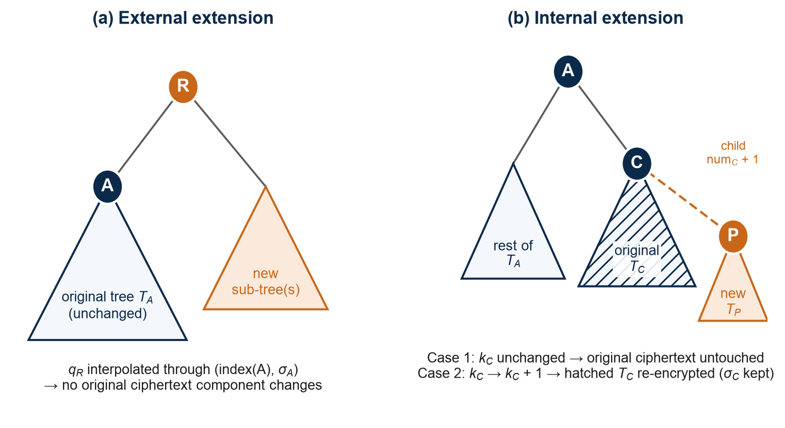
Fig. 3. (a) External extension: a new root R is added above the original tree. (b) Internal extension: a new sub-tree P becomes child num_{C} + 1 of node C.

Section 4: Security Analysis
The authors prove EH-CP-ABE secure against Chosen-Ciphertext Attacks (IND-CCA) in the random oracle model, assuming that the symmetric scheme (E, D) is IND-CCA secure and that the Computational Bilinear Diffie-Hellman (CBDH) assumption holds: given (g, gᵃ, gᵇ, gᶜ) for random a, b, c, no probabilistic polynomial-time adversary can compute e(g,g)ᵃᵇᶜ with non-negligible advantage. The proof constructs a simulator B that embeds the CBDH instance into the public parameters (implicitly setting α = α' + ab and β = b) and answers key queries by implicitly setting the key randomness r = r′ − a; H₁, H₂ and decryption queries are answered from lists of random-oracle values that it controls. When the adversary submits its IND-CCA guess, B extracts a candidate value for e(g,g)ᵃᵇᶜ from the adversary's H₂ query list and uses it to solve the underlying CBDH instance. The reduction shows that if the adversary wins the IND-CCA game with advantage ε, B solves CBDH with advantage ε/q_H2, where q_H2 is the number of H₂ queries — so breaking the scheme is at least as hard as breaking CBDH.
The paper also remarks (Remark 3) that querying keys for several different attribute sets gives the adversary no more knowledge of the challenge ciphertext, so the scheme resists collusion. Since the adversary knows neither an attribute set satisfying T* nor the random value σ used for the challenge, it also cannot extend the challenge ciphertext to a new access structure through ExExtension or InExtension.
Note on the scope of the proof. The challenge ciphertext in the security game protects a single message under one access structure T*. The proof therefore does not address what is new in the hierarchical setting: whether the message of one sub-tree stays hidden from a key that satisfies a different, related sub-tree. Section 7.3 shows that in general it does not.

Section 5: Comparative Study
The paper compares EH-CP-ABE against the file-hierarchy scheme of Wang et al. [4], the extendable-policy scheme of Susilo et al. (EACSIP) [5], and the extendable-policy scheme of Huang et al. (DACSC) [6]. Table 1 summarizes the qualitative feature comparison.
Table 1. Feature comparison (after Table I of [10]).
Feature | Wang et al. [4] | Susilo et al. [5] | Huang et al. [6] | EH-CP-ABE (this paper)
Access structure | Tree | LSSS | Tree | Tree
Hierarchical encryption | Yes (level-based) | No | No | Yes (any subtree)
External extension | No | Yes (OR-gate only) | Yes (OR/AND-gate) | Yes (AND/OR/OUT-OF)
Internal extension | No | No | No | Yes
Provable security | IND-CPA | IND-CPA | IND-CPA | IND-CCA

Wang et al.'s scheme achieves hierarchical encryption but only by forcing files onto successive levels of the tree via extra transport nodes, and supports no extension at all. Susilo et al. and Huang et al. support extending the policy of the same piece of data (which the authors note is a special case of the general extension problem this paper solves) but neither considers hierarchical multi-data encryption, and neither reaches IND-CCA security. EH-CP-ABE is the only scheme in the comparison offering hierarchical encryption, both directions of extension, and IND-CCA security simultaneously, subject to the caveat on sub-policy enforcement in Section 7.3.
Table 2 reproduces the paper's computational-cost comparison (Table II of [10]). EH-CP-ABE's Encrypt cost, (2|T| + 2|X|)·E, is additive in the size of the tree and the number of data items, whereas Susilo et al. [5] and Huang et al. [6] pay for the whole policy again for every data item (a factor |X|), and Wang et al. [4] additionally pays 2j|S|·E for its transport nodes. ExExtension and InExtension in EH-CP-ABE cost only (2|T_{E}| + 2|X′|)·E — proportional to the newly added structure, not the whole tree (for InExtension Case 2 this figure leaves out the re-encryption of the sub-tree below C; see Section 3.4) — and no other scheme supports internal extension at all. For communication cost, the paper's Table III gives EH-CP-ABE a ciphertext of (|X| + 2|T|)·|𝔾₀| + |X|·|𝔾_{T}|, which, unlike [5] and [6], does not multiply the policy size by the number of data items, and avoids the transport-node terms of [4].
Table 2. Comparison of computational cost (from Table II of [10]).
Algorithm | Wang et al. [4] | Susilo et al. [5] | Huang et al. [6] | EH-CP-ABE [10]
Setup | 2E + P | 2E + P | 5E + P | 2E + P
KeyGen | (2|γ| + 2)·E | (|γ| + 3)·E | (2|γ| + 2)·E | (2|γ| + 2)·E
Encrypt | (2|T| + 2|X| + 2j|S|)·E | (3|T| + 5)·|X|·E | (2|T| + 5)·|X|·E | (2|T| + 2|X|)·E
Decrypt | (2|γ| + 1)·P | (2|γ| + 3)·P + 2|γ|·E | (2|γ| + 2)·P | (2|γ| + 1)·P
ExExtension | — | (3|T_{E}| + 5)·|X′|·E | ① (2|T_{E}| + 2)·|X′|·E  ② (2|T_{E}| + 4)·|X′|·E | (2|T_{E}| + 2|X′|)·E
InExtension | — | — | — | (2|T_{E}| + 2|X′|)·E
E: one exponentiation; P: one pairing; |γ|: number of attributes in the key; |T|: attribute scale of the access structure; |X|: number of data items encrypted; |T_{E}|, |X′|: the same quantities for the structure added by an extension; j, |S|: children per transport node and number of transport nodes in [4]. For [6], ① is the non-restrictive and ② the restrictive extension; “—” means not supported.

Section 6: Performance Evaluation
The authors implemented EH-CP-ABE in Java using the Java Pairing-Based Cryptography (JPBC) library, on a Type-A curve with a 160-bit group order, AES-256 for symmetric encryption, and a representative ~300 KB PDF as the payload; every measurement is averaged over 1000 runs on an Intel Core i5 2.3 GHz / 8 GB machine.
- KeyGen and Decrypt scale linearly with the number of attributes (10 to 100); decryption time reaches about 1.1 s at 100 attributes, which the authors consider acceptable.
- Encrypt for a single file tracks the baseline CP-ABE scheme of Bethencourt et al. almost exactly — the hierarchical machinery adds negligible overhead for a single data item.
- Hierarchical encryption vs. separate encryption of 10 files: for 300 KB files, separate encryption takes ~23 s versus ~5 s for hierarchical encryption; for 300 MB files, ~30 s versus ~9 s. The saving grows with both the number of files and the file size.
- With the original access structure fixed at 50 attributes, external and internal extension (Case 1) are consistently about 2 s faster than encrypting the same enlarged policy from scratch, because only the newly added part of the tree is processed.
- Internal extension Case 2 (threshold update) costs scale with how many nodes of the original sub-tree must be re-encrypted — from ~0.6 s when only 10 attributes need updating, up to ~4.3 s (matching full re-encryption of the 110-attribute policy) if all 100 original attributes need updating. This is the one situation where extension offers little to no saving.
Overall, the experiments support the paper's central efficiency claim: hierarchical batch encryption and lightweight extension substantially reduce computation for a data owner who regularly shares families of related data, at the cost of some overhead in the rarer case of internal extension that forces a threshold update.

Section 7: Implementation and Verification
To check the scheme beyond reading the paper, we implemented all six algorithms in Python (repository linked on the first page). The implementation uses the BLS12-381 pairing from the py_ecc library [14], the standard hash-to-curve method [15] for H₁, SHA-256 for H₂, and AES-256-GCM for (E, D). It comes with 25 unit tests and a benchmark script that re-runs the experiments of Section VI of the paper. Table 3 maps the paper's algorithms to the code.
Table 3. The paper's algorithms in the implementation (module ehcpabe.scheme).
Paper | Function | Original ciphertext
Setup | setup() | —
KeyGen | keygen(pp, msk, attrs) | —
Encrypt (Alg. 1) | encrypt(pp, tree, messages) | —
Decrypt | decrypt(...), decrypt_all(...) | —
ExExtension (Alg. 2) | ex_extend(...) | unchanged
InExtension Case 1 (Alg. 3) | in_extend(..., raise_threshold=False) | unchanged
InExtension Case 2 (Alg. 4) | in_extend(..., raise_threshold=True) | nodes strictly below C re-encrypted

7.1 Implementation Choices
- Pairing group. The paper uses a symmetric (Type-A) pairing e: 𝔾₀ × 𝔾₀ → 𝔾_{T}. BLS12-381 is asymmetric, e: 𝔾₁ × 𝔾₂ → 𝔾_{T}, so each element is placed on the side that makes every pairing in Decrypt line up: C_{x}⁽²⁾, C_{y} and D′_{i} in 𝔾₁; C′_{y}, D and D_{i} in 𝔾₂ (H₁ hashes onto 𝔾₂). The algebra is then the paper's with e(g, g) replaced by e(g₁, g₂). The curve has a 255-bit group order (about 120-bit security by current estimates), against the paper's 160-bit Type-A curve.
- Symmetric layer. K_{x} = H₂(C_{x}⁽¹⁾ ‖ C_{x}⁽²⁾ ‖ R̂_{x}) is a 256-bit AES-GCM key. GCM is authenticated and K_{x} binds C_{x}⁽¹⁾ and C_{x}⁽²⁾, so modifying any of the three components makes decryption fail, which matches the paper's requirement that (E, D) be IND-CCA secure.
- Owner state. The paper has the owner keep σ_{x} = q_{x}(0) for each non-leaf node. But internal extension Case 1 sets q_{P}(0) = q_{C}(num_{C} + 1), which needs every coefficient of q_{C}, not only σ_{C}. The implementation therefore keeps the full polynomial of every non-leaf node, plus each K_{x}, so that Case 2 can re-encrypt the affected M_{x} without being handed the plaintexts again. OwnerState.seal() encrypts this state under an owner-held AES key, as the paper suggests for C_{σ}.
- Decrypt runs the Miller loops for all needed pairings, applies the Lagrange exponents before the final exponentiation, and performs one final exponentiation per recovered message. When one key opens several sub-trees, DecNode results are shared between them.
Most tests run on the tree of Fig. 2. They check that each key recovers exactly the messages whose sub-policies it satisfies; that two users who each hold half of a policy cannot pool their key components (collusion resistance); that ExExtension and InExtension Case 1 leave every original ciphertext component unchanged; that Case 2 changes only the components strictly below C; that tampered ciphertexts are rejected; and that the observation of Section 7.3 holds, including the cases described there. All 25 tests pass.

7.2 Experimental Results
The benchmarks ran on an Apple M1 laptop (8 GB RAM) under Python 3.15, with a 300 KB random payload as in the paper, averaging 3 runs per point (one run for the 30 MB series; the paper averages 1000), so individual points are somewhat noisy. Absolute times differ from the paper's Java figures in both directions: KeyGen, Encrypt and the extensions are somewhat faster here, while Decrypt, which is dominated by pairings, is several times slower, as pairings are the slowest operation in the pure-Python py_ecc library. We therefore compare trends rather than seconds. Table 4 puts the headline numbers side by side.
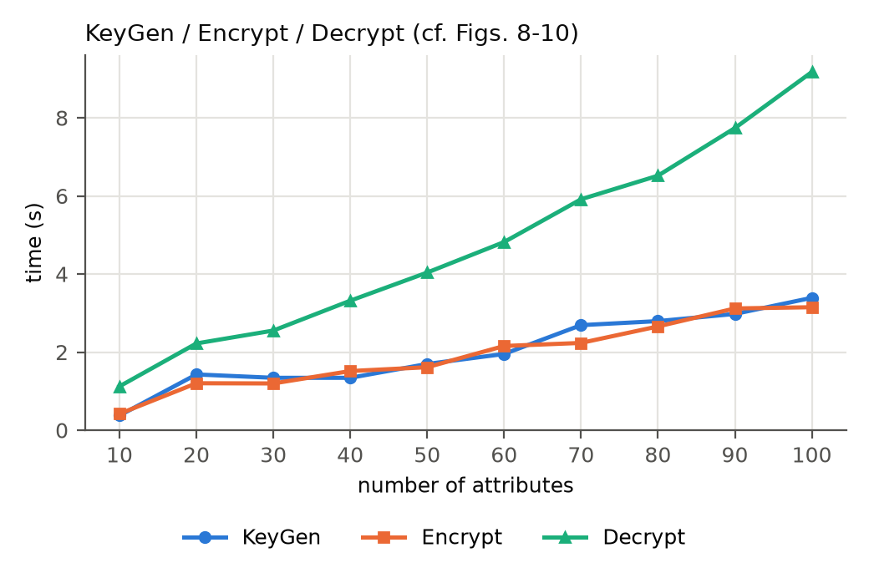
Fig. 4. KeyGen, Encrypt (one file) and Decrypt against the number of attributes (cf. Figs. 8–10 of [10]).
KeyGen, Encrypt and Decrypt all grow linearly with the number of attributes (Fig. 4), as in the paper. Here Decrypt is the most expensive of the three (9.2 s at 100 attributes), because it needs two pairings per attribute; in the paper it is the cheapest (about 1.1 s, against about 4 s for KeyGen and Encrypt).
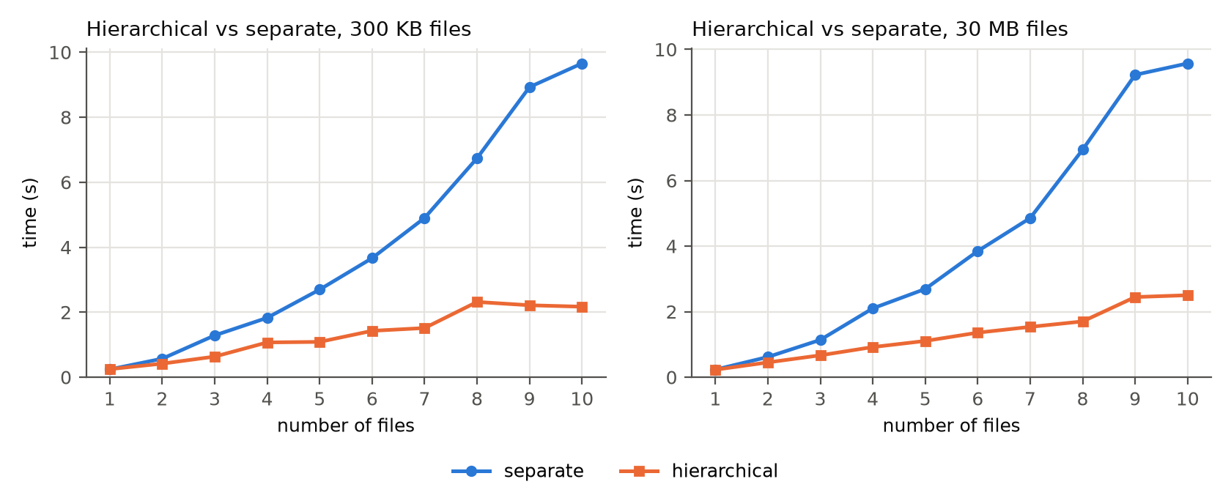
Fig. 5. Hierarchical against separate encryption of 1–10 nested files, 5 attributes per level; 300 KB files (left) and 30 MB files (right) (cf. Fig. 11 of [10]).
Hierarchical encryption is the scheme's main efficiency claim, and it holds (Fig. 5). Encrypting 10 nested files separately costs 9.7 s against 2.2 s for one hierarchical pass, a factor of 4.5 (the paper reports about 23 s against 5 s, a factor of 4.6). Separate encryption re-shares the inner policies once per file, so its cost grows quadratically with the number of nested files, while hierarchical encryption grows linearly. With 30 MB files the times are 9.6 s and 2.5 s: the symmetric encryption is the same in both approaches, so the gap still comes from the attribute-based part.
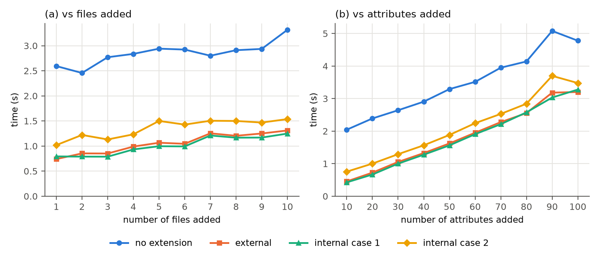
Fig. 6. Extension against encryption without extension, original policy of 50 attributes: (a) adding 1–10 files that carry 20 attributes in total; (b) adding one file of 10–100 attributes. Case 2 attaches under a node that covers 10 of the original attributes (cf. Figs. 12–14 of [10]).
For extension (Fig. 6), encrypting the enlarged policy from scratch always pays for the 50 original attributes again, while external extension and internal extension Case 1 only process the added part. Across the attribute sweep they are on average 1.6 s and 1.7 s faster than encryption without extension, a roughly constant gap like the paper's 2 s. Case 2 additionally re-encrypts the 10 original attributes under the extended node, so it sits a little above Case 1. In panel (a), with the number of added attributes fixed, each extra file adds only one more C_{x} triple and one AES encryption, so the extension costs rise slowly (0.74 s to 1.31 s for external extension) and stay well below encryption without extension.
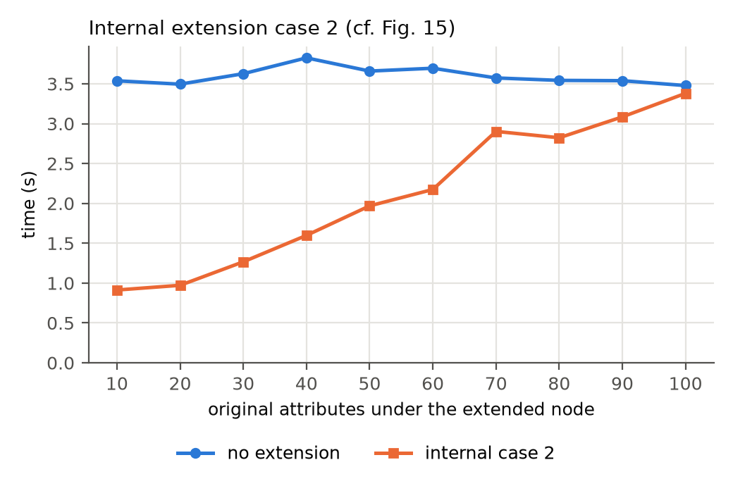
Fig. 7. Internal extension Case 2 against encryption without extension, as the number of original attributes under the extended node grows (100 original + 10 added attributes; cf. Fig. 15 of [10]).
Fig. 7 reproduces the paper's Fig. 15. Case 2 costs 0.91 s when 10 original attributes sit under the extended node and rises linearly to 3.4 s when that node covers all 100, against 3.5 s for encryption without extension. As in the paper's Fig. 15, Case 2 saves the most when the extended node covers only a small part of the original tree.
Table 4. Headline results: the paper (Java, JPBC, 160-bit Type-A curve) and this implementation (Python, py_ecc, BLS12-381).
Experiment | Paper [10] | This implementation
Decrypt, 100 attributes | ≈ 1.1 s | 9.2 s
10 files, separate vs hierarchical (300 KB) | ≈ 23 s vs 5 s (4.6×) | 9.7 s vs 2.2 s (4.5×)
External extension vs no extension (50-attr. original, +50 attr.) | ≈ 2 s faster | 1.6 s vs 3.3 s (1.7 s faster)
Case 2, 10 vs 100 attributes updated | ≈ 0.6 s → 4.3 s | 0.9 s → 3.4 s
Case 2 with all attributes updated vs no extension | equal (≈ 4.3 s) | 3.4 s vs 3.5 s

7.3 An Observation: Sub-Policies Are Not Always Enforced
While writing the tests we found that the hierarchical construction does not always enforce the sub-policy of a data item. In Encrypt, the secret of a node is a point on its parent's polynomial, σ_{x} = q_{parent(x)}(index(x)). Decrypt gives a user who satisfies a gate P the values e(g,g)^{rβ·q_P(j)} for k_{P} different indices j, one per satisfied child. Lagrange interpolation in the exponent works at any point, not only at 0, so the same user can also compute e(g,g)^{rβ·q_P(index(x))} = DecNode(x) for every child x of P, and from it R̂_{x}, K_{x} and M_{x}, whether or not their attributes satisfy T_{x}. That value is in turn the point at 0 of q_{x}, so the effect compounds down the tree: a data item is effectively protected by a weaker policy than its own whenever any gate above it is an OR or k-of-n gate.
On the tree of Fig. 2 this has concrete effects, all reproduced by the tests using only public ciphertext components and the user's own key. A key holding only b1 satisfies T_{B} = b1 OR T_{D} and recovers M_{D}, although T_{D} requires d1, d2 and d3 (below an OR gate the polynomial is a constant, so σ_{D} = σ_{B}). A key holding {b1, a1} satisfies the 2-of-3 gate A and recovers M_{C} without c1 or c2. The effect also spans levels: under G = g1 OR P with P = 2-of-(p1, p2, X), a key holding {g1, p1} satisfies neither T_{X} nor T_{P}, yet recovers M_{X}. The extensions inherit the effect: after an OR-gate external extension, users who satisfy only the new branch recover the original M_{A}; after internal extension Case 1, users who satisfy the original T_{C} recover the new M_{P}, since q_{P}(0) = q_{C}(num_{C} + 1) is just one more point on q_{C}.
A data item is protected by exactly its own policy only when every gate on the path from the root down to it is an AND gate, because then a user can reach the secret of a node only by satisfying that node's policy. The paper's motivating example in Section I (T_{B} = “task X” AND T_{A}) is of this kind and is unaffected; trees with OR or OUT-OF gates above a data item, which the paper explicitly supports (Section III-C), are not. The security proof misses the issue because its challenge ciphertext carries a single message under T*, so it never asks whether one sub-tree's message stays hidden from a key that satisfies another sub-tree. Fixing it for general gates seems to need randomness for each data item that is independent of its parent's polynomial, which would give back part of the efficiency gain. We leave this open. The issue concerns who can decrypt, not how long the operations take, so it does not affect the timings in Section 7.2.

Section 8: Conclusion and Future Directions
EH-CP-ABE extends the classical tree-based CP-ABE construction of Bethencourt et al. in two complementary directions: it lets a data owner encrypt a whole family of hierarchically related data items in a single pass by exploiting every internal node of the access tree, and it lets the owner extend that tree — externally or internally — to admit new data under a broadened policy while reusing most or all of the original ciphertext. The scheme is proven IND-CCA secure in the random oracle model under the CBDH assumption (given an IND-CCA-secure symmetric cipher), its experiments show that it keeps the efficiency of the non-hierarchical CP-ABE baseline [3] while greatly reducing the cost of encrypting related data, and its cost analysis shows lower encryption and ciphertext costs than the closest prior schemes [4]–[6] as the number of encrypted data items grows.
Our implementation confirms these efficiency claims qualitatively: hierarchical encryption beats separate encryption by a growing margin, and extension costs only the added part of the policy, except for Case 2 updates high in the tree. It also shows two points the paper leaves implicit. The data owner must keep each node's full polynomial, not only σ_{x}, to perform internal extension Case 1. More importantly, a data item below an OR or k-of-n gate can be decrypted by anyone who satisfies that gate, so in practice every gate above a data item should be an AND gate until the construction is fixed.
The authors note one limitation as future work: ciphertext size in EH-CP-ABE grows linearly with the size of the access policy, which is typical of tree-based CP-ABE but worse than ABE schemes built on linear secret-sharing schemes (LSSS) with constant-size ciphertext. However, those constant-size schemes update the entries of the sharing matrix whenever the policy is extended, which forces re-encryption of everything derived from the old shares — defeating the purpose of cheap extension. Designing a CP-ABE scheme that achieves both constant-size ciphertext and efficient policy extension is left as an open problem.

References
[1] A. Sahai and B. Waters, “Fuzzy identity-based encryption,” in Proc. EUROCRYPT, 2005, pp. 457–473.
[2] V. Goyal, O. Pandey, A. Sahai, and B. Waters, “Attribute-based encryption for fine-grained access control of encrypted data,” in Proc. ACM CCS, 2006, pp. 89–98.
[3] J. Bethencourt, A. Sahai, and B. Waters, “Ciphertext-policy attribute-based encryption,” in Proc. IEEE Symp. Security and Privacy, 2007, pp. 321–334.
[4] S. Wang, J. Zhou, J. K. Liu, J. Yu, J. Chen, and W. Xie, “An efficient file hierarchy attribute-based encryption scheme in cloud computing,” IEEE Trans. Inf. Forensics Security, vol. 11, no. 6, pp. 1265–1277, 2016.
[5] W. Susilo, P. Jiang, F. Guo, G. Yang, Y. Yu, and Y. Mu, “EACSIP: Extendable access control system with integrity protection for enhancing collaboration in the cloud,” IEEE Trans. Inf. Forensics Security, vol. 12, no. 12, pp. 3110–3122, 2017.
[6] Q. Huang, N. Li, and Y. Yang, “DACSC: Dynamic and fine-grained access control for secure data collaboration in cloud computing,” in Proc. IEEE GLOBECOM, 2018, pp. 1–7.
[7] C. Gentry and A. Silverberg, “Hierarchical ID-based cryptography,” in Proc. ASIACRYPT, 2002, pp. 548–566.
[8] G. Wang, Q. Liu, and J. Wu, “Hierarchical attribute-based encryption for fine-grained access control in cloud storage services,” in Proc. ACM CCS, 2010, pp. 735–737.
[9] Z. Wan, J. Liu, and R. H. Deng, “HASBE: A hierarchical attribute-based solution for flexible and scalable access control in cloud computing,” IEEE Trans. Inf. Forensics Security, vol. 7, no. 2, pp. 743–754, 2012.
[10] M. Xiao, H. Li, Q. Huang, S. Yu, and W. Susilo, “Attribute-based hierarchical access control with extendable policy,” IEEE Trans. Inf. Forensics Security, vol. 17, pp. 1868–1883, 2022.
[11] Y. Jiang, W. Susilo, Y. Mu, and F. Guo, “Ciphertext-policy attribute based encryption supporting access policy update,” in Proc. 10th Int. Conf. (ProvSec) (Lecture Notes in Computer Science), vol. 10005, L. Chen and J. Han, Eds. Nanjing, China: Springer, 2016, pp. 39–60.
[12] Y. Jiang, W. Susilo, Y. Mu, and F. Guo, “Ciphertext-policy attribute-based encryption supporting access policy update and its extension with preserved attributes,” Int. J. Inf. Secur., vol. 17, no. 5, pp. 533–548, Oct. 2018.
[13] J. Li et al., “An efficient attribute-based encryption scheme with policy update and file update in cloud computing,” IEEE Trans. Ind. Informat., vol. 15, no. 12, pp. 6500–6509, Dec. 2019.
[14] Ethereum Foundation, “py_ecc: Python implementation of ECC pairing and bn_128 and bls12_381 curve operations,” https://github.com/ethereum/py_ecc.
[15] A. Faz-Hernández, S. Scott, N. Sullivan, R. S. Wahby, and C. A. Wood, “Hashing to elliptic curves,” RFC 9380, IETF, Aug. 2023.

